© Kevin Horecka 2018

Spatiotemporal Reconstruction and Navigation and Relational Memory in the Hippocampus

By

Kevin Michael Horecka

Dissertation

Submitted in partial fulfillment of the requirements  
for the degree of Doctor of Philosophy in Neuroscience  
in the Graduate College of the  
University of Illinois at Urbana-Champaign, 2018  
  
  
  
  
  
  
  
  
Urbana, Illinois

Doctoral Committee:

Professor Neal J. Cohen, Chair  
 Visiting Principle Research Scientist Rama Ratnam  
 Associate Professor Aron K. Barbey  
 Associate Professor Arne Ekstrom, University of Arizona

**Abstract**

<TODO>

*To my wife, friends, and family*

*And*

*All of my mentors and teachers*

**Acknowledgements**

<TODO>

Contents

[Contents 1](#_Toc496269621)

[Introduction 1](#_Toc496269622)

[Domains and Entities: Building Systematic Understanding of Reconstruction 2](#_Toc496269623)

[Properties of Domains 3](#_Toc496269624)

[Properties of Entities 4](#_Toc496269625)

[Illustratability Does Not Define Domains of Information 5](#_Toc496269626)

[Domains Other than Space and Time 5](#_Toc496269627)

[Overview of Properties of Domains and Entities 6](#_Toc496269628)

[Domains 6](#_Toc496269629)

[Entities 6](#_Toc496269630)

[2D Spatial Reconstruction – The iPosition Task 7](#_Toc496269631)

[Relational Invariance under Transformations 8](#_Toc496269632)

[Precision and Identity Information 9](#_Toc496269633)

[Sampling and Encoding During Study 10](#_Toc496269634)

[Overview of Chapters 11](#_Toc496269635)

[Reconstructing Relational Information 11](#_Toc496269636)

[Spatiotemporal Navigation, Sampling, and Information Encoding in Virtual Reality 11](#_Toc496269637)

[Reconstructing Relational Information Placeholder 12](#_Toc496269638)

[Memory during Time Travel: Spatiotemporal Navigation, Contextual Boundaries, and Relational Memory Errors in Virtual Reality Placeholder 13](#_Toc496269639)

[Spatiotemporal Navigation, Sampling, and Information Encoding in Virtual Reality 14](#_Toc496269640)

[Discussion 15](#_Toc496269641)

[References 16](#_Toc496269642)

# Introduction

There are numerous ways to quantify memory efficacy, but when it comes to recollective memory few methods are richer or more detailed than reconstruction tasks (Huttenlocher & Presson, 1979). Reconstruction tasks ask individuals to study some information and then, after a delay, recreate the information they saw. Traditionally, individuals are given some information such as a set of items which are to be reconstructed and a domain within the reconstruction should occur. The goal of the analysis from the experimenter’s perspective is to then take the resulting behavioral information and make inferences to determine aspects of the original information which were or weren’t remembered, the degree to which they were remembered, and any systematic distortion which may be present in that memory. Ultimately, we cannot know what precise thoughts, strategies, or information the participant did or did not have when performing the task, but by carefully deciding the assumptions we are willing to make, we can strongly infer what was not done in the reconstruction (because if it were, the performance should have been better). Moreover, by systematically analyzing the performance in reconstruction, we can begin to hypothesize about global properties of memory organization and representation which should be present across many different domains of information. In addition to a theoretical introduction to assumptions and perspectives on reconstruction tasks, this work goes on to show how performance on reconstruction tasks can be broken down to elucidate some aspects of memory in two particular domains, space and time. Specifically, in the spatial domain, our data shows that specific types of relational information are impaired in hippocampal damaged individuals (Chapter 1). Additionally, the data shows that in healthy adults, there may be differences in spatial and temporal domains in how representations are structured, and in either domain additional sources of information (such as contextual information) can bias representations (Chapter 2). Finally, this work discusses how sampling of an environment might influence memory performance in reconstruction (Chapter 3).

## Domains and Entities: Building Systematic Understanding of Reconstruction

In order to be more systematic about our effort to understand reconstruction, we should first break down our problem into its most fundamental components. This may, on some level, feel like a trite exercise, but if we can establish a confident understanding of the basic elements of reconstruction, this will make the process of deciding assumptions in order to strengthen our inferences less arduous. First, we can define reconstruction in its most basic as containing two main components, a *domain* which can have a variety of properties which we will outline shortly, and *entities* which are embedded in this domain. It is, of course, possible and entirely inevitable that multiple types of domains and entities will interact, but for the sake of our understanding of the mental representations which are involved in reconstruction, it is helpful to restrict our focus to instances in which only one domain and one type of entity is present, at least for now.

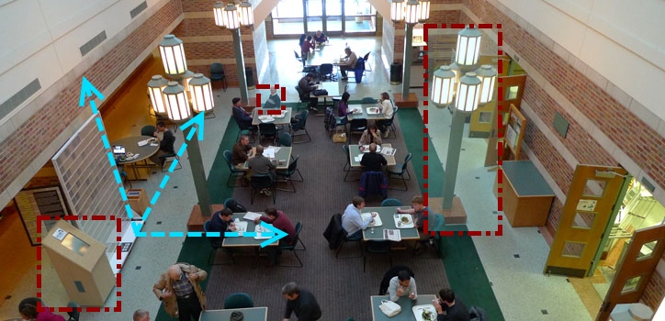

The Beckman Institute; an example of a 3D spatial domain populated by numerous entities which occupy specific points in space and have various identities.

#### Properties of Domains

At this point, it is useful to stop and pick a specific example to which we can link the abstract terms defined in the previous paragraph to clarify their meaning. Imagine a 2D spatial domain on a computer screen or table. Within this spatial domain exists items, i.e. discrete entities which have a precisely defined location on the table and locations relative to one-another. If we consider the number of restrictions we have already made, we can begin to understand how difficult the problem of a systematic breakdown of reconstruction is. First, the reader may have implicitly assumed (likely, rightfully so due to my examples) that the 2D space in question is finite. However, this was never explicitly stated. An infinite space opens up a variety of new problems of scale and geometry which we may or may not want to address. For example, is this space a toroidal ring like we see in video games such as the classic, Asteroids? Is it a 2D space wrapped on a sphere like we experience on maps from day-to-day (i.e. the earth)? Similarly, although I have explicitly defined the number of dimensions, I was not clear on the topology and geometry of these dimensions. Is this a Euclidean space? A hyperbolic space (a la a Penrose diagram in theoretical physics) where distance becomes asymptotically large as I approach the boundaries? Or something more exotic?

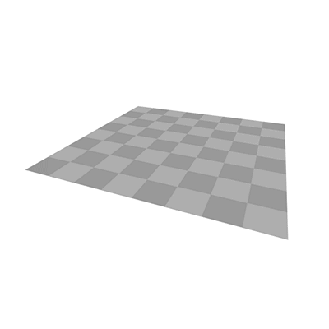 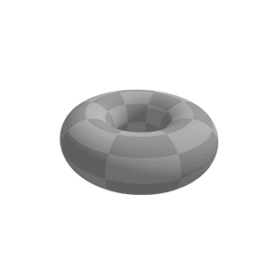 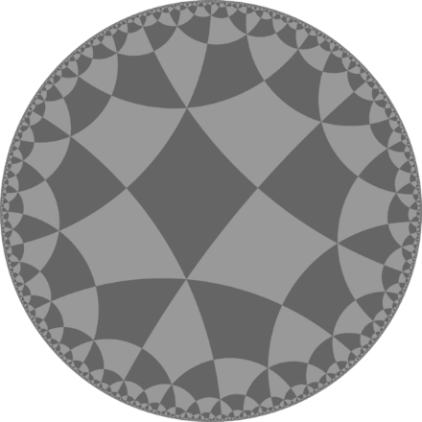

Examples of spaces with different geometries. Euclidean, toroidal, and hyperbolic. From <http://blog.andreahawksley.com/170517301/> originally and latest from <https://en.wikipedia.org/wiki/File:Torus_from_rectangle.gif> and <https://en.wikipedia.org/wiki/File:H2chess_246a.png> . Also see <https://upload.wikimedia.org/wikipedia/commons/c/cb/Hyperbolic_domains_3222.png> .

Properties of Entities  
Now what of the entities? They have already been restricted to have a precisely defined location, so entities which occupy multiple locations simultaneously have been eliminated. However, do the entities have identities or are they anonymous? Are they equally likely to be positioned in the center of the space or near the boundaries? Can they be positioned in precisely the same location? Many of these questions are simply assumed to be answered a particular way when the experiment could have just as easily been designed another way. These systematic assumptions that both experimenter and participant make may seem unimportant as, if both parties make the same assumptions, it should not confound the results. However, what of participants which are unable to remember some information due to an impairment like hippocampal damage? Perhaps, without the ability to precisely remember information about the locations of the entities, patients with hippocampal damage will fall back to these core assumptions and perform the task via heuristic. There is mounting evidence that hippocampal damage impairs precision in spatial memory (Kolarik et al., 2016; Kolarik, Baer, Shahlaie, Yonelinas, & Ekstrom, 2017; Yonelinas, 2013), so this suggestion is not farfetched. How accurate can one be with only the heuristic that items will not often be near the boundary and will never be too close together? Although we might be tempted to call such a performance “random”, by acknowledging when our own assumptions of our task might become violated in a systematic way, we might gain insight into the sorts of information processing which is and is not impaired with damage to certain brain regions, and, by extension, we may better understand neural information processing as a whole.

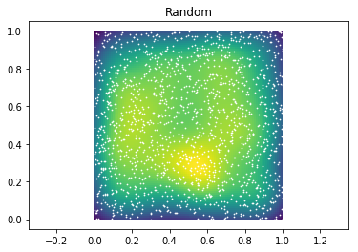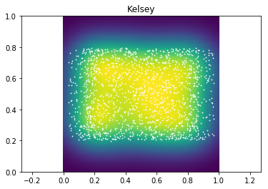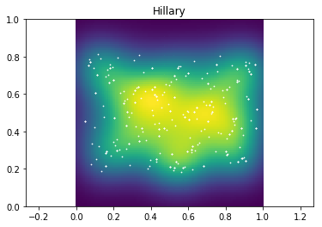 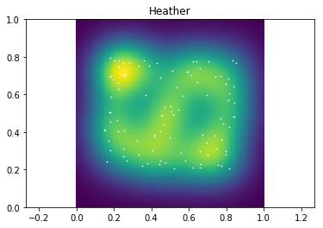

Examples of heatmaps of item placement with different constraints. From left to right: random placement, random placement with aspect ratio constraint, random placement avoiding boundaries, random placement with a distance constraint (i.e. items must be a certain distance apart).

#### Illustratability Does Not Define Domains of Information

Another critical assumption often made in reconstruction is the types of domains and entities which might be involved. Typically, reconstruction tasks have involved space (as illustrated above) and items (sometimes with identities). However, this is, once again, an arbitrary imposition on what reconstruction is. Before enumerating examples of domains and entities which go beyond these examples, it’s useful to take a moment to consider why these may be so dominant. Reality, as we observe it, is intrinsically experienced in 3 spatial dimensions and 1 temporal dimension. All information of any type which we observe will exist, embedded in these 4 dimensions. This is often used as an argument as to why these must be the critical dimensions to neural systems, and perhaps, on some level, they are. However, it is incredibly restrictive to allow the definitions of domains which could be encoded to only be those which can be illustrated. Illustration requires, by its very nature, embedding whatever domain or idea is being observed into the observable 4D world. However, the set of all possible representable information need not be bound to what can be illustrated. An analogous situation happens when we imagine the dimensionality of data. We cannot easily illustrate data beyond 3 dimensions. We can add color, animation, shape, size, and all sorts of other illustrative methods, but we can always add more dimensions to the data. If we stopped accepting dimensions beyond those that can be illustrated as easily as we stop accepting domains of information, much of the powerful mathematics used in the world today would be out of our reach. It is not a necessary precondition for a brain to represent information which can be illustrated.

#### Domains Other than Space and Time

So what other domains exist and might be of interest beyond space? Obviously, time is an additional domain, but once again, we’ve limited ourselves to the illustratable dimensions. Social space, as defined by the relative affiliation and power between individuals (Eichenbaum, 2015; Tavares et al., 2015), is another possible abstract space and has been investigated in the context of hippocampal function, finding that hippocampal fMRI activation in the hippocampus located characters in a 2D power-affiliation “map”. Color can be thought of as an abstract space independent of space and time (Warren, Duff, Cohen, & Tranel, 2015). Of course, it is tempting to fall back into old habits and think of color as being on a 1D line, with the x axis defined as hue, and social space being illustrated via a scatter plot in 2 dimensions. These are useful illustrations, but domains of information are only illustrated to help us understand them. Their illustration does not define them. Additionally, although time has been discussed as if it can be easily lumped in with space up until now, it obviously has its own interesting properties. Time is intrinsically unidirectional. Time is continuous, and motion through it is obligatory. Few other domains have this property, and as such, time may be of special interest. Moreover time cells have been identified in the hippocampus (B. Kraus, Robinson, White, Eichenbaum, & Hasselmo, 2013) which act much like place cells but activate corresponding with particular moments in time. Although it is difficult to disentangle temporal firing from spatial or distance firing, via careful task design, cells which fire to time and distance in exclusion of one another (as well as cells which fire for both) have been identified (B. J. Kraus et al., 2015) in the hippocampus. Together these pieces begin to paint a picture of a hippocampus in which entities can be bound within and across a variety of domains. Indeed, previous work has shown the hippocampus is critical for all manner (i.e. domain) of relations (Konkel, Warren, Duff, Tranel, & Cohen, 2008).

#### Overview of Properties of Domains and Entities

Before proceeding to the interactions of domains and entities and how we measure memory for these elements, let’s enumerate some of the properties of domains and entities which are being assumed in some way:

|  |  |
| --- | --- |
| Domains | Entities |
| **Finite vs. Infinite** (i.e. there are boundaries or not)  **C:\Users\Kevin\AppData\Local\Microsoft\Windows\INetCache\Content.Word\finite_infinite.png** | **Precisely Located**  (i.e. their position can be defined by one point) & **Encapsulated/Finite**  (i.e. they occupy a finite space)  C:\Users\Kevin\AppData\Local\Microsoft\Windows\INetCache\Content.Word\position.png |
| **Continuous vs. Discrete** (i.e. any location is valid or only some are)  **C:\Users\Kevin\AppData\Local\Microsoft\Windows\INetCache\Content.Word\discrete_continuous.png** | **Distribution**  (i.e. entities are more likely in some areas)  C:\Users\Kevin\AppData\Local\Microsoft\Windows\INetCache\Content.Word\scatter.png |
| **Dimensionality** (i.e. there are multiple of the same domain type)  C:\Users\Kevin\AppData\Local\Microsoft\Windows\INetCache\Content.Word\dimensions.png | **Constraint**  (i.e. positions of entities are relative to others) |
| **Geometry/Topology**  (i.e. Euclidean, toroidal, hyperbolic)  C:\Users\Kevin\AppData\Local\Microsoft\Windows\INetCache\Content.Word\H2chess_246a.pngC:\Users\Kevin\AppData\Local\Microsoft\Windows\INetCache\Content.Word\Untitled-1.png | **Identity**  (i.e. they are anonymous or labelled)  C:\Users\Kevin\AppData\Local\Microsoft\Windows\INetCache\Content.Word\identities.png |
| **Single Domain vs. Multi-Domain**  (i.e. two domains are simultaneously present)  C:\Users\Kevin\AppData\Local\Microsoft\Windows\INetCache\Content.Word\rainbow.png |  |
| **Disjoint vs. Connected**  (i.e. can all space be reached from anywhere)  C:\Users\Kevin\AppData\Local\Microsoft\Windows\INetCache\Content.Word\3dfigs.png |  |

#### 2D Spatial Reconstruction – The iPosition Task

Properties of Domains and Entities. This list is not necessarily exhaustive, but these properties represent some critical assumptions being made during any reconstruction task.

Now, with a specific example, we can begin to form a clear definition of what information within a reconstruction we can infer and using what techniques. We will begin with a common scenario: a finite, continuous, 2D, Euclidean, spatial, connected domain (i.e. a computer screen) populated with 6, precisely located, finite, randomly distributed pictures of real-world objects which will not overlap/appear on top of one another and are sampled from a finite set of possible objects. What information is present in this scenario – in other words, if we wanted to perfectly recreate a particular instance of this scenario, how many numbers would we need at a minimum? Let’s begin with the location information. A naïve approach would be to represent each of the 6 items with 2 numbers (x and y) and, assuming we have a list of the possible objects (or at least an understanding of the objects which are currently present), 1 additional number is needed to define the identity of each entity. So in our naïve case, we can represent all 6 items with 18 numbers.

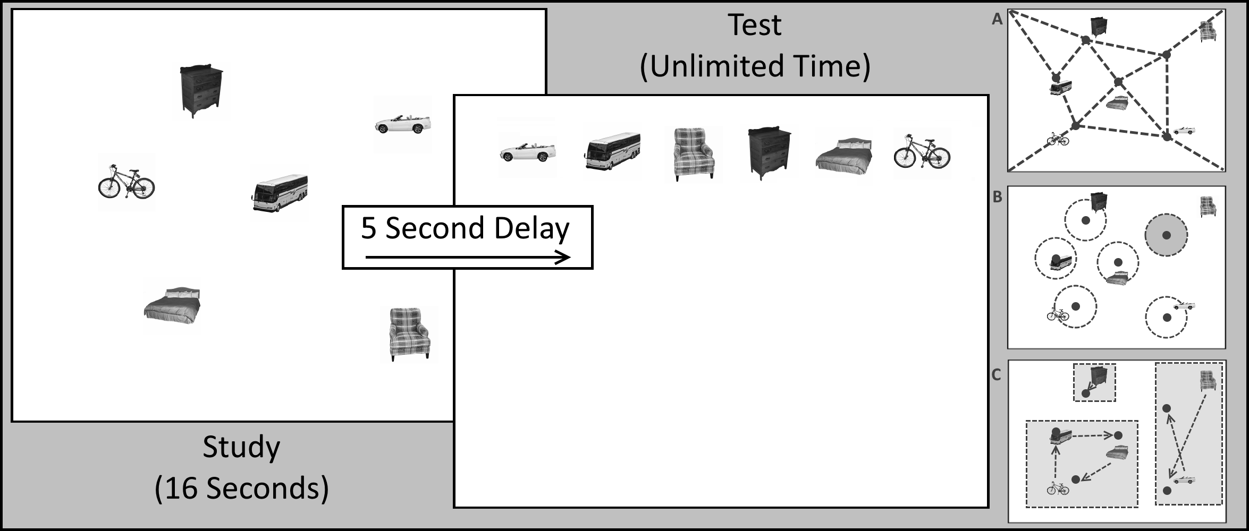

Example Reconstruction Task: a finite, continuous, 2D, Euclidean, spatial, connected domain populated with 6, precisely located, finite, randomly distributed pictures of real-world objects which will not overlap/appear on top of one another and are sampled from a finite set of possible objects. Note that the study portion is timed, there is a short delay, then the test has unlimited time. These are constraints on sampling the environment and maintaining memory more than the information contained within the configuration.

#### Relational Invariance under Transformations

First, for location information, if the intent is to reconstruct an original configuration of these items, a precise reconstruction will require all 12 location numbers to be represented. However, for an approximate representation, a much more compressed option may be available. Suppose the positions of each element were encoded into a graph-like representation where the relations between a subset of the items was encoded instead of any explicit location. Now, if the graph can be represented more efficiently, only one position need be remembered precisely (i.e. the overall position of the graph within the environment). Moreover, with this representation, the positions can now be transformed in ways which are not obvious given a set of 6 unassociated points. For instance, if the space were to be scaled up or down (as was done in Muller & Kubie, 1987 in rodents), the relative relations would simply be scaled up or down in accordance (and in fact, Muller & Kubie showed that place cell firing in an open field remapped with scaling, maintaining the relative shape of spatial firing). If the space were to be translated, the graph does not change and only the global position would need to be adjusted. In fact, within a space like the one we’ve defined, scaling and translation are the fundamental transformations which will not require alteration of the graph of relative positions. Rotation, sheering, or other more complex transformations can potentially result in the relative positions of items being changed, but with scaling and translation, any item to the left of another will remain to the left, and any item on top will remain on top. This idea parallels some from physics and mathematics where certain quantities are conserved (or invariant) under certain transformations. Noether’s theorem (Noether, 1971), in fact, specifically states that for any transformation (specifically, those which are differential symmetries of an action), there is some corresponding conservation law (conservation of energy is equivalent to translational symmetry in time, conversation of moment is translational symmetry in space, conservation of angular momentum is rotational symmetry in space, etc.). If we believe memory for the location information which describes a set of points is encoded in such a relational graph, we should similarly believe that the representation should only be conserved under those transformations which have relational invariance (i.e. scaling and translation) but not those which lack such an invariance (i.e. rotation and sheering). Moreover, we might suspect that transformations which conserve parts of the relational information (like reflection, which conserves relations on all but the reflected axis) might have a graded effect on memory for the locations.

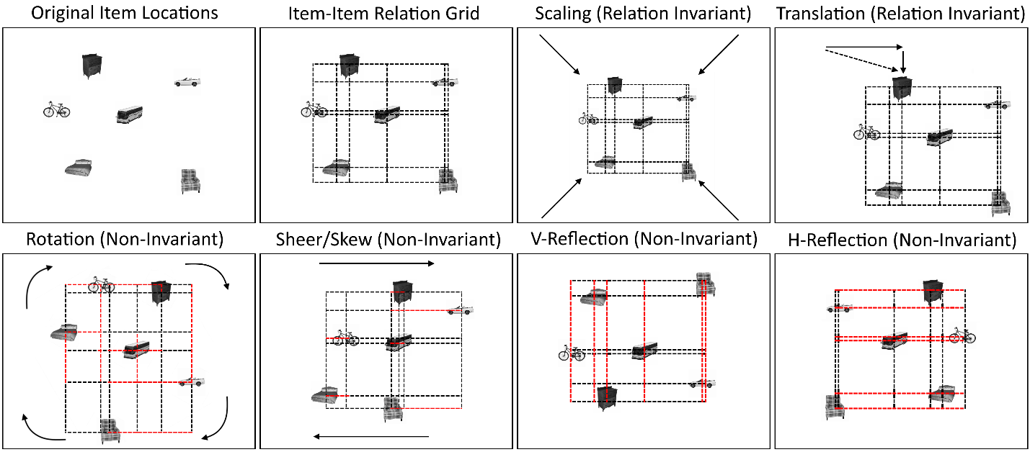

Relational Invariance in Affine Transformation Components in 2D: Note that via an item-item relational grid, we can observe the impact of different transforms on the relations present between items. Scaling and Translation have no impact on the relations between items (though scaling impacts distance between items. On the other hand, Rotation, Sheer/Skew, and Vertical/Horizontal Reflection all can modify relations in some systematic way. However, rotation uniquely can modify both dimensions relations.

#### Precision and Identity Information

Of course, the precision of the memory for the graph position and for the relational information may vary as well, but this can be treated as different types of noise which can be quantified in particular ways. The Precision and Binding Model (Yonelinas, 2013) suggests that the hippocampus is critical for binding precise, high resolution information, and the associated measures of precision used in testing this model (a variable sized accuracy window) is one example of a quantification method which shows promise (Kolarik et al., 2016, 2017). However, this model addresses precision in continuous domains, not precision for discrete information, and it does not address the specifics of how different binding configurations might influence memory. Moreover, because the theory addresses behavior in a Virtual Morris Water Maze with a platform as the target entity, there is no identity information and no item-item relational information (item-environment relational information is present in the form of platform-landmark relations). Relational memory theory (Cohen & Eichenbaum, 1993), on the other hand, very directly addresses how memory for arbitrary relations might form a flexible representation (in the graph-like manner discussed previously). However, even once we accept that a graph-like representation is at the core of memory for reconstruction, the problem is still far from solved. We don’t know, for instance, if a subset of the items are being represented relationally, bound to each other, while a single item is being bound to some aspect of the environment in exclusion of the other items. Additionally, the presence of higher-order organizational information (such as contextual information) might bias the reconstruction in ways which are measurable in the change of position of the groups of entities which share that higher-order property. The exact definition of context, however, is a topic of heavy debate and will not be resolved in this work.

Now, for identity information, we also have several possibilities. If the identity information is being convolved with some aspect of the spatial information, we would expect it to be subject to the same transformation and invariance rules outlined in the previous paragraph. If, however, the items are being bound to particular locations, these bindings might be subject to their own conservation rules. This situation is more likely if the items are arbitrary, i.e. they just as easily could have been any item. Arbitrary items cannot be as easily convolved with location as no expectancy can be formed about what item should be associated with a given location. In reality, arbitrary items may still end up with alternative associations by chance (for instance, if an image of a plane happens to appear over an image of a tree, this obviously has a location-identity association which is non-arbitrary as planes tend to fly over trees, but it may have occurred by chance), but if the items are arbitrary, we can imagine them, in some way, as a disjoint domain of their own which must be bound to the continuous, connected domain of space. This binding may not be damaged by transformation of the space as it is being done via creating arbitrary relations from single points to identities. The various identities, however, could end up confused in some way if that information was not remembered but the location information was. In this way, particular identities might be assigned to the wrong location, or identities might switch places. If the relations are arbitrary, these errors should be thought of as distinct from the sorts which might result from some failure to remember location.

#### Sampling and Encoding During Study

Finally, the discussion up until now has been exclusive to the representational and retrieval portion of memory, but it largely neglects the encoding aspect of reconstruction. When performing a reconstruction task, individuals are given some amount of time to study the information. During this time, there are numerous behaviors which might be performed in order to attempt to gather the information. The structure of human sensory systems is such that we generally sample specific aspects of information one-at-a-time, rather than assimilating the whole environment simultaneously. This sampling behavior is of particular interest as it is imminently measurable. If the information being studies is all visual (such as a computer screen task), the eyes will be the only sampling medium and, as such, the movement of the eyes in some way determines the information which can be encoded. In Virtual Reality or Real-World environments, navigation (the combination of body-movement and eye-movement) provides a more flexible form of sampling. In either case, sampling comes down to a stream of information which is received by the system whose contents can be guided by in-the-moment demands. If the task at hand has few demands, very little sampling will be required, however, in a demanding task, extensive sampling may be required to acquire the necessary information. Task are sometimes designed to require participants to sample particular aspects of an environment (via masking all but some small region of the environment or by forcing the participant to acknowledge sampling of particular aspects of the environment before proceeding, for example), and these demands may also bias behavior in particular ways. Sampling is a complicated topic, and as such, it will only be examined in relation to the test performance and not in a more holistic, information rich way.

## Overview of Chapters

The remainder of this document will discuss algorithmic and mathematical formulations of these ideas for the aforementioned example of 2D space and show that, as hinted at earlier, hippocampal damage does uniquely impair some but not all of these measures of performance in reconstruction (Chapter 1). Later sections will extend these methods to a temporal domain and show how, despite its differences, it might be treated in much the same way as we treat space (Chapter 2). However, temporal and spatial domains may share many similarities, but errors in each may be distinct in other ways which can be seen in reconstruction performance. In particular, contextual information may have a similar influence on memory in both space and time, when it comes to precise remembering of location information, but relational information may be in some way different in these two domains. Finally, we will examine aspects of sampling of a domain which might influence the ability to remember and reconstruct information (Chapter 3).

#### Reconstructing Relational Information

<todo>

*Memory during Time Travel: Spatiotemporal Navigation, Contextual Boundaries, and Relational Memory Errors in Virtual Reality*

<todo>

#### Spatiotemporal Navigation, Sampling, and Information Encoding in Virtual Reality

<todo>

# Reconstructing Relational Information Placeholder

# Memory during Time Travel: Spatiotemporal Navigation, Contextual Boundaries, and Relational Memory Errors in Virtual Reality Placeholder

# Spatiotemporal Navigation, Sampling, and Information Encoding in Virtual Reality

# Discussion

# References

Cohen, N. J., & Eichenbaum, H. (1993). *Memory, Amnesia, and the Hippocampal System.* Cambridge: MIT Press.

Eichenbaum, H. (2015). The Hippocampus as a Cognitive Map ... of Social Space. *Neuron*, *87*(1), 9–11. http://doi.org/10.1016/j.neuron.2015.06.013

Huttenlocher, J., & Presson, C. C. (1979). The coding and transformation of spatial information. *Cognitive Psychology*, *11*(3), 375–394. http://doi.org/10.1016/0010-0285(79)90017-3

Kolarik, B. S., Baer, T., Shahlaie, K., Yonelinas, A. P., & Ekstrom, A. D. (2017). Close but no cigar: Spatial precision deficits following medial temporal lobe lesions provide novel insight into theoretical models of navigation and memory. *Hippocampus*, (August), 1–11. http://doi.org/10.1002/hipo.22801

Kolarik, B. S., Shahlaie, K., Hassan, A., Borders, A. A., Kaufman, K. C., Gurkoff, G., … Ekstrom, A. D. (2016). Impairments in precision, rather than spatial strategy, characterize performance on the virtual Morris Water Maze: A case study. *Neuropsychologia*, *80*, 90–101. http://doi.org/10.1016/j.neuropsychologia.2015.11.013

Konkel, A., Warren, D. E., Duff, M. C., Tranel, D. N., & Cohen, N. J. (2008). Hippocampal amnesia impairs all manner of relational memory. *Frontiers in Human Neuroscience*, *2*(October), 15. http://doi.org/10.3389/neuro.09.015.2008

Kraus, B. J., Brandon, M. P., Robinson, R. J., Connerney, M. A., Hasselmo, M. E., & Eichenbaum, H. (2015). During Running in Place, Grid Cells Integrate Elapsed Time and Distance Run. *Neuron*, *88*(3), 578–589. http://doi.org/10.1016/j.neuron.2015.09.031

Kraus, B., Robinson, R., White, J., Eichenbaum, H., & Hasselmo, M. (2013). Hippocampal “Time Cells”: Time versus Path Integration. *Neuron*, *78*(6), 1090–1101. http://doi.org/10.1016/j.neuron.2013.04.015

Muller, R. U., & Kubie, J. L. (1987). The effects of changes in the environment on the spatial firing of hippocampal complex-spike cells. *The Journal of Neuroscience : The Official Journal of the Society for Neuroscience*, *7*(7), 1951–68. Retrieved from http://www.ncbi.nlm.nih.gov/pubmed/3612226

Noether, E. (1971). Invariant variation problems. *Transport Theory and Statistical Physics*, *1*(3), 186–207. http://doi.org/10.1080/00411457108231446

Tavares, R. M., Mendelsohn, A., Grossman, Y., Williams, C. H., Shapiro, M., Trope, Y., & Schiller, D. (2015). A Map for Social Navigation in the Human Brain. *Neuron*, *87*(1), 231–243. http://doi.org/10.1016/j.neuron.2015.06.011

Warren, D. E., Duff, M. C., Cohen, N. J., & Tranel, D. (2015). Hippocampus contributes to the maintenance but not the quality of visual information over time. *Learning & Memory*, *22*(1), 6–10. http://doi.org/10.1101/lm.037127.114

Yonelinas, A. P. (2013). The hippocampus supports high-resolution binding in the service of perception, working memory and long-term memory. *Behavioural Brain Research*, *254*, 34–44. http://doi.org/10.1016/j.bbr.2013.05.030